Software Requirement Specification

of

Travel Management System

Submitted by:

**Amir Maharjan**

Semester:

**BCA 4th Semester**

Submitted to

Subject Teacher:

**Leena Maharjan**

Date:

­­­­­­­­­­­_____________________

Table of Contents

**Introduction** 1

**1.1.** **Purpose** 1

**1.2.** **Document Convention** 1

**1.3.** **Project Scope** 1

**1.4.** **Definition and Abbreviation** 2

**1.5.** **References** 2

**Overall Description** 3

**2.1** **Product Perspective** 3

**2.2** **Product Features** 3

**2.3** **User Classes and Characteristics** 4

**2.4** **Operating Environment** 5

**2.5** **Assumptions and Dependencies** 5

**External Interface Requirement** 6

**Non-Functional Requirements** 7

# **Introduction**

## **Purpose**

The purpose of this software requirement specification (SRS) document is to illustrate the requirements of the project Travel Management System. The purpose of this project is to provide a platform where the users will be able to book their travels to their desired trekking destinations, give their reviews, share their photos and videos, etc. The document describes the functional and non-functional requirement of the project.

## **Document Convention**

* Entire document should be justified.
* Entire document should have space after each paragraph
* Line spacing should be 1.15 or 1.5
* Left margin of the document should be 1.15 or 1.5
* Convention for Main Title
* Font Size: - 16
  + Font Family: - Times New Roman
  + Font Style: - Bold
* Convention for Sub Title
* Font Size: - 14
* Font Family: - Times New Roman
* Font Style: - Bold
* Convention for Body
* Font Size: - 12
* Font Family: - Times New Roman
* Font Style: - Normal
* Figure Captions should be italic

## **Project Scope**

Travel Management System is basically a website where travelers will be able to view individual price or group prices, availability, best seasons to travel, difficulty, etc. of their desired trekking destinations.

The purpose of Travel Management System is to ease travel management and to create a friendly environment where the travels can share their experiences and memories. There is no restriction on who can use the website, anyone who wants to travel or has plans to travel in the future can use this website to gain information about their desired destination.

As a poor and small south Asian country, people are not used to travelling a lot. This project will provide a platform where they will be able to travel at affordable prices. This project will also provide traveler reviews, photos, videos, etc. so that it can inspire other people to travel and explore new destinations.

## **Definition and Abbreviation**

* TMS: Travel Management System
* SRS: Software Requirement Specification

## **References**

* SRS for Library Management System by Soumili Sen, Nayan Patil, Neha Singh, Anita Singh.
* <http://www.krazytech.com>
* <http://www.nepaltrekkingexperts.com>
* <http://www.makemytrip.com>
* <http://www.booking.com>

# **Overall Description**

## **Product Perspective**

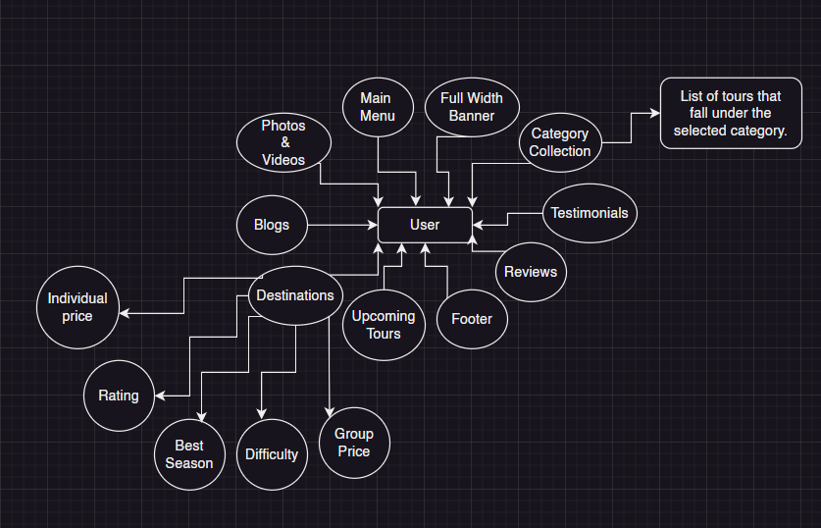

*Fig: User’s Perspective*

## **Product Features**

The features of the system are as follows:

1. **Captivating Frontend design**

As the famous quotes states “You never get a second chance to make a good first impression”. The first thing the user notices when they enter the system is the design.

1. **Super-fast**

What’s the point of creating a system that is slow? In this fast-paced modern era the users are not going to wait for the system to load. The users will instead find another system that will do their tasks faster.

1. **Video playlist**

A picture is worth a thousand words. A short video may as well be worth a million words. Share a video that will inspire other people to travel and explore the world.

1. **User friendly**

A website has to be user friendly. It is a basic requirement. It’s a requirement because the helps in getting maximum customer satisfaction, save user time and effort and listen to less critics.

## **User Classes and Characteristics**

The system provides different types of services according to the user. The user may be an admin, an editor or a subscriber. The admin as the name suggests will have all the available services, the editor however will act like an admin but will not have the same authority and the subscribers are the normal users who will be able stuff like submit a form, post photos, videos, etc.

The features available for the admin are: -

1. Can add as many editors, to help with admin work.
2. Add users
3. Can view full user details (editors are not authorized).
4. Can decide what data will be displayed on the frontend.
5. Send notifications to the users.

The features available for the editors are: -

1. Can add users.
2. Backend design of the system.
3. Can view partial user details that are not vulnerable.
4. Decide which data will be displayed on which section.
5. Can categorize the contents.

The features available for the users are: -

1. Frontend Design
2. View other user reviews
3. View other users’ photos and videos
4. View package details
5. Can as questions.

## **Operating Environment**

The system will be operational on all the available systems like windows, mac, etc. The system is built using PHP, JavaScript, jQuery, CSS, HTML, AJAX, etc. All browsers such as chrome, brave, edge, Firefox, etc. are compatible.

## **Assumptions and Dependencies**

The assumptions are:

1. The code should be error free.
2. Should be user-friendly and easy to use.
3. The code should implement DRY principle.
4. Maximum code readability should be showcased.
5. Fast retrieval of data from the database
6. Should have search facility

The following dependencies are:

1. The user information should be stored in database correctly.
2. Any update on user information should also be stored in database.
3. Basic hardware and software required.
4. A stable internet connection.

# **External Interface Requirement**

Login Interface:

In case the user is not registered, the user should be taken to the registration page where they will fill out some required field such as username, password, email, phone number, etc. After filling out the form and submitting it, they will able to login into our system and freely use the system.

Category View:

To find a pin in a pile of rubbish we simple use a magnet. The category view will act as a magnet, where if a user wants to visit Tibet, they can simply view the Tibet Tours category and find the listed tours.

Reviews:

The main purpose of the reviews section is to let the new users know what the previews users think about the tours and travels.

Gallery

A section to showcase the memories and experiences of previous users.

# **Non-Functional Requirements**

Some non-functional requirements of the system are as follows:

1. Safety Requirements

The system is created using PHP, a relatively old programming language. So, it is vulnerable for virus attacks. The database is also a target for such attacks. A proper firewall and necessary safety steps should be taken.

1. Security Requirements

The information that the users provide when the register or book, should be properly stored as there is always a chance that bug or virus may appear and destroy the system. The information should back up.

1. Performance

The performance of the system solely depends on how big the system is. The less code the lighter the system. Performance also depends on external factors such good internet connection, good hardware and software, etc.